SESSION13

SUBJECT: BLACK BOX TESTING TECHNIQUES (PART 2)

Question 1: Create a decision table for a Flipkart-style coupon validation system where a coupon is only valid if: (1) the user is logged in, (2) the cart value is above ₹500, and (3) the coupon has not expired. Show all possible combinations and the resulting action (accept/reject).
Answer:

1. Introduction
A decision table is a black-box testing technique used to represent different combinations of conditions and their corresponding actions. It helps testers identify test cases for business rules and verify that the system behaves correctly for each combination.
In a Flipkart-style coupon validation system, a coupon is accepted only when all three conditions are satisfied:
- The user is logged in.
- The cart value is above ₹500.
- The coupon has not expired.
If any condition is false, the coupon must be rejected.

2. Decision Table
Here, Y = Yes/True and N = No/False.
Conditions / Rules | Rule 1 | Rule 2 | Rule 3 | Rule 4 | Rule 5 | Rule 6 | Rule 7 | Rule 8
User logged in? | Y | Y | Y | Y | N | N | N | N
Cart value above ₹500? | Y | Y | N | N | Y | Y | N | N
Coupon not expired? | Y | N | Y | N | Y | N | Y | N
Action: Accept coupon | Yes | No | No | No | No | No | No | No
Action: Reject coupon | No | Yes | Yes | Yes | Yes | Yes | Yes | Yes

3. Explanation
- Rule 1: All three conditions are true, so the coupon is accepted.
- Rule 2: The coupon has expired, so it is rejected.
- Rule 3: The cart value is not above ₹500, so the coupon is rejected.
- Rule 4: The cart value is too low and the coupon has expired, so it is rejected.
- Rule 5: The user is not logged in, so the coupon is rejected.
- Rule 6: The user is not logged in and the coupon has expired, so it is rejected.
- Rule 7: The user is not logged in and the cart value is too low, so it is rejected.
- Rule 8: None of the three conditions is satisfied, so the coupon is rejected.

Conclusion: The decision table contains all (2^3 = 8) possible combinations of the three Boolean conditions. Only one combination allows the coupon to be accepted. This makes coupon validation easier to test systematically.

Question 2: Draw a state transition diagram for a Paytm login feature that locks the account after 3 failed password attempts and only unlocks after a successful OTP verification.

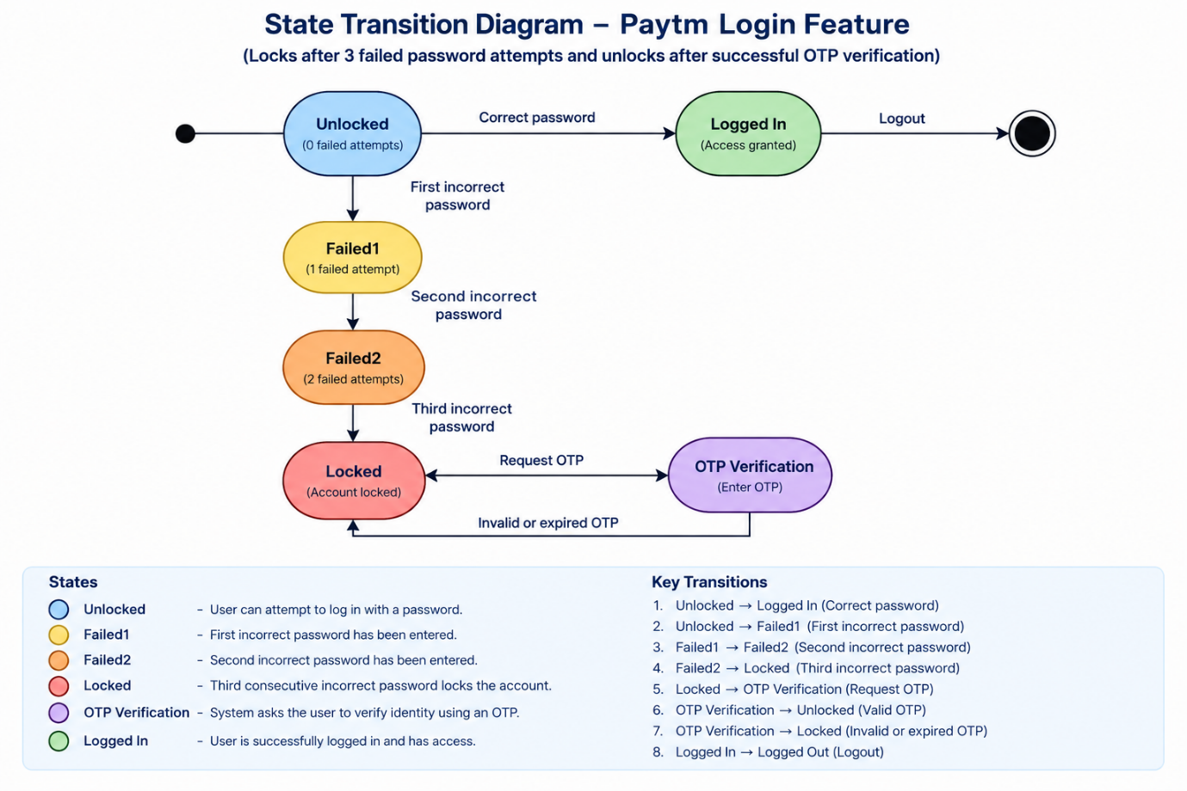
Answer:

1. Introduction
State Transition Testing is a black-box testing technique used to verify how a system changes from one state to another in response to events or inputs.
For a Paytm-style login feature, the system tracks failed password attempts. After three consecutive failed attempts, the account becomes locked. A successful OTP verification is required to unlock it.

2. State Transition Diagram
<CodeBlock language="mermaid" editable> stateDiagram-v2 [*] --> Unlocked Unlocked --> LoggedIn: Correct password Unlocked --> Failed1: First incorrect password Failed1 --> LoggedIn: Correct password Failed1 --> Failed2: Second incorrect password Failed2 --> LoggedIn: Correct password Failed2 --> Locked: Third incorrect password LoggedIn --> [*] Locked --> OTPVerification: Request OTP OTPVerification --> Unlocked: Valid OTP OTPVerification --> Locked: Invalid or expired OTP </CodeBlock>

3. Explanation of States
- Unlocked: The user can attempt to log in with a password.
- Failed1: The first incorrect password has been entered.
- Failed2: The second incorrect password has been entered.
- Locked: The third consecutive incorrect password locks the account.
- OTP Verification: The system asks the user to verify their identity using an OTP.
- Logged In: A correct password entered before the account is locked allows access.

4. State Transition Table
Current State | Event / Input | Next State | Expected Result
Unlocked | Correct password | Logged In | User logs in successfully.
Unlocked | First incorrect password | Failed1 | Failed attempt count becomes 1.
Failed1 | Second incorrect password | Failed2 | Failed attempt count becomes 2.
Failed2 | Third incorrect password | Locked | Account is locked.
Locked | Request OTP | OTP Verification | OTP verification process begins.
OTP Verification | Valid OTP | Unlocked | Account is unlocked and the user may retry login.
OTP Verification | Invalid or expired OTP | Locked | Account remains locked.

5. Important Test Scenarios
- Verify that a correct password allows login before the account is locked.
- Verify that the first and second incorrect attempts do not lock the account.
- Verify that the third consecutive incorrect attempt locks the account.
- Verify that a valid OTP unlocks the account.
- Verify that an invalid or expired OTP does not unlock the account.
- Verify that login attempts remain blocked while the account is locked.

Conclusion: The state transition diagram describes how the login system moves between unlocked, failed-attempt, locked, OTP-verification, and logged-in states. It helps testers verify account security and ensure that only successful OTP verification unlocks a locked account.

Question 3: Given the following use case: 'A Zomato user can place an order, cancel it before it is prepared, or track the order once prepared,' create a use case diagram and list at least 3 possible test scenarios based on it.
Answer:

1. Introduction
A use case diagram is a UML (Unified Modeling Language) diagram that shows the interactions between actors and the functions of a system.
For a Zomato-style food delivery application, the primary actor is the User, who can place an order, cancel an order before preparation, and track an order once it has been prepared.

2. Use Case Diagram
<CodeBlock language="mermaid" editable> flowchart LR U[User] subgraph Z["Zomato Food Delivery System"] P([Place Order]) C([Cancel Order]) T([Track Order]) end U --- P U --- C U --- T </CodeBlock>

3. Explanation of Use Cases
Use Case 1: Place Order
The user selects a restaurant, chooses food items, provides the required order details, and confirms the order. The system records the order and displays its status.
Use Case 2: Cancel Order
The user requests cancellation before the restaurant starts preparing the order. The system checks the order status and cancels it if cancellation is allowed.
Use Case 3: Track Order
Once the order has been prepared, the user can view the order's progress and delivery status according to the application's tracking rules.

4. Test Scenarios Based on the Use Cases
Test Case ID | Test Scenario | Steps | Expected Result
TC_ZOM_001 | Verify that a user can place an order successfully. | 1. Open the application. 2. Select a restaurant. 3. Add food items to the cart. 4. Confirm the order. | The order should be created successfully and an order confirmation should be displayed.
TC_ZOM_002 | Verify that a user can cancel an order before it is prepared. | 1. Place an order. 2. Open the order details. 3. Request cancellation while the order is not yet prepared. | The order should be cancelled, and its status should update accordingly.
TC_ZOM_003 | Verify that a user cannot cancel an order after preparation has started. | 1. Place an order. 2. Change or wait for the order status to indicate preparation has started. 3. Attempt cancellation. | The system should prevent cancellation through this feature or follow its defined cancellation policy.
TC_ZOM_004 | Verify that a user can track an order once it has been prepared. | 1. Place an order. 2. Open the order tracking screen after preparation. | The system should display the available order and delivery status accurately.

Conclusion: The use case diagram shows the User interacting with the Place Order, Cancel Order, and Track Order functions. The test scenarios verify successful ordering, permitted and restricted cancellation, and order tracking.

Question 4: Modify your decision table from Task 1 to include an additional rule: the coupon cannot be used more than twice by the same user. Update the table and explain how this new rule changes the possible outcomes. Hint: Add a column for 'Coupon Usage Count' and adjust the actions accordingly.
Answer:

1. Introduction
The original decision table checked three conditions: login status, cart value, and coupon expiry. The new rule adds a fourth condition: the coupon cannot be used more than twice by the same user.
For this assignment, the coupon is accepted only if:
- The user is logged in.
- The cart value is above ₹500.
- The coupon has not expired.
- The user's previous usage count for the coupon is fewer than two uses.
Therefore, a user who has already used the coupon twice cannot use it again.

2. Updated Decision Table
Y = Yes/True; N = No/False. The usage count means the number of times the same user has previously used this coupon.
Conditions / Rules | Rule 1 | Rule 2 | Rule 3 | Rule 4 | Rule 5
User logged in? | Y | Y | Y | Y | N
Cart value above ₹500? | Y | Y | Y | Y | Y
Coupon not expired? | Y | Y | Y | N | Y
Coupon usage count | 0 | 1 | 2 | 0 | 0
Action: Accept coupon | Yes | Yes | No | No | No
Action: Reject coupon | No | No | Yes | Yes | Yes

3. Explanation of Updated Rules
- Rule 1: The user is logged in, the cart value is above ₹500, the coupon is valid, and the user has not used it before. The coupon is accepted.
- Rule 2: All required conditions are satisfied, and the user has used the coupon only once previously. The coupon is accepted for the second use.
- Rule 3: The user has already used the coupon twice. The coupon is rejected even though the other conditions are satisfied.
- Rule 4: The coupon has expired, so it is rejected.
- Rule 5: The user is not logged in, so the coupon is rejected.

4. How the New Rule Changes the Possible Outcomes
The new usage-count condition adds another reason for rejecting a coupon. Previously, the coupon could be accepted whenever all three original conditions were true. Now, the user must also have used the coupon fewer than two times.
For example:
- Usage count 0: Eligible for the first use.
- Usage count 1: Eligible for the second use.
- Usage count 2 or more: Rejected because the maximum number of uses has already been reached.
With four Boolean conditions, a fully expanded decision table could contain (2^4 = 16) combinations. However, coupon usage count is actually a numeric value, so it is more meaningful to test the groups fewer than two uses and two or more uses, along with the other conditions.

5. Additional Test Cases
Test Case ID | User Logged In? | Cart Value | Coupon Expired? | Previous Usage Count | Expected Result
TC_COUP_001 | Yes | ₹700 | No | 0 | Accept
TC_COUP_002 | Yes | ₹700 | No | 1 | Accept
TC_COUP_003 | Yes | ₹700 | No | 2 | Reject
TC_COUP_004 | Yes | ₹500 | No | 0 | Reject
TC_COUP_005 | Yes | ₹700 | Yes | 0 | Reject
TC_COUP_006 | No | ₹700 | No | 0 | Reject

Conclusion: The additional usage-count rule prevents a user from applying the same coupon more than twice. It introduces another condition that must be satisfied before acceptance and requires new test cases for first use, second use, and attempted third use.

